**UNIT-I**

**Multiple Choice Questions**

Note: **All the correct answer for each question is indicated by a  symbol.**

**1. Topic: IP Datagram, IP fragmentation**

1. The ________ protocol is the transmission mechanism used by the TCP/IP suite.

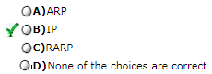

1. IP is _________ datagram protocol.

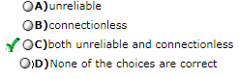

1. The term ________ means that IP provides no error checking or tracking. IP assumes the unreliability of the underlying layers and does its best to get a transmission through to its destination, but with no guarantees.

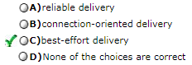

1. A best-effort delivery service such as IP includes _______.

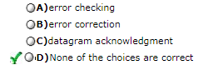

1. An HLEN value of decimal 10 means _______.

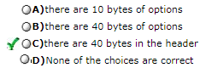

1. If the fragment offset has a value of 100, it means that _______.

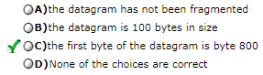

1. What is needed to determine the number of the last byte of a fragment?

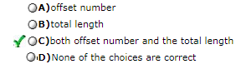

1. The IP header size _______.

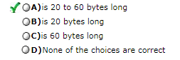

1. Packets in the IP layer are called _________.

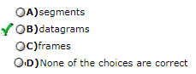

1. The total length field defines the total length of the datagram _________.

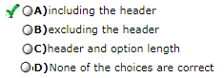

1. When a datagram is encapsulated in a frame, the total size of the datagram must be less than the _______.

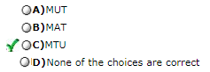

1. Which IP option is used if exactly four specific routers are to be visited by the datagram?

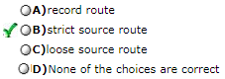

1. For the timestamp option, a flag value of _______ means that each visited router adds only the timestamp in the provided field.

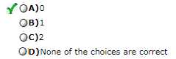

1. The IP header field formerly known as the service type field is now called the _______ field.

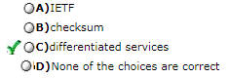

1. The _______ module takes fragments of a message and puts them back in order.

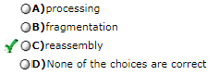

1. The _______ module sends out an IP packet, the next-hop address, and interface information.

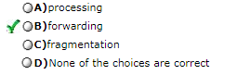

1. The _______ module discards datagrams with a TTL value of zero.

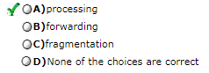

1. The output of the _______ module is an IP packet destined for an upper-layer protocol.

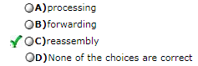

1. The _______ module consults the MTU table to determine the packet size necessary for transmission.

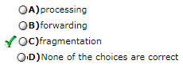

1. The value of the ________ subfield in an option controls the presence of the option in fragmentation.

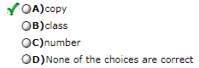

1. The value of the ________ subfield defines the general purpose of an option.

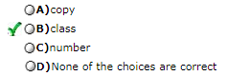

1. The value of the ________ subfield defines the types of an option.

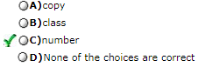

1. Only ______ end of option option can be used in a datagram.

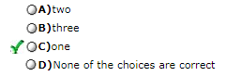

1. When we use IP over ATM, only the ________ cell carry(ies) the 8-byte trailer added to the IP datagram.

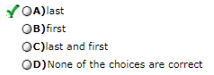

1. When we use IP over ATM, padding can be added only to the _____ or the _______.

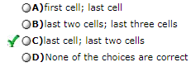

1. To find the physical address of the exiting-point router, ATM uses the services of _________.

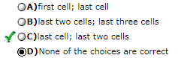

1. The inverse request and inverse reply messages can bind the physical address to an IP address in a(n) _______ situation.

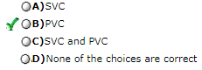

1. The request and reply message can be used to bind a physical address to an IP address in a(n) _______ situation.

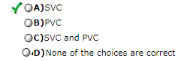

1. __________ allows an ATM network to be divided into several logical subnets.

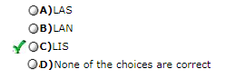

**2. Topic: ARP, RARP**

1. A _______ address is an internetwork address with universal jurisdiction.

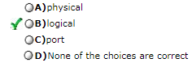

1. The logical addresses in the TCP/IP protocol suite are called _______ addresses.

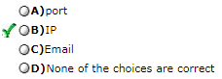

1. A ________ is a local address. Its jurisdiction is over a local network.

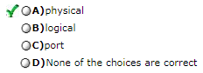

1. If the sender is a host and wants to send a packet to another host on the same network, the logical address that must be mapped to a physical address is ______.

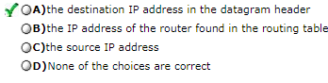

1. If the sender is a host and wants to send a packet to another host on another network, the logical address that must be mapped to a physical address is ______.

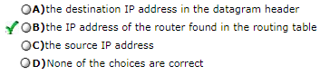

1. The sender is a router that has received a datagram destined for a host on another network. The logical address that must be mapped to a physical address is ______.

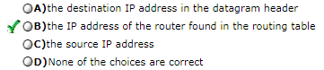

1. The sender is a router that has received a datagram destined for a host in the same network. The logical address that must be mapped to a physical address is ______.

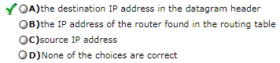

1. In _______, a table associating a logical address with a physical address is updated manually.

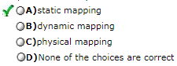

1. The target hardware address on an Ethernet is _______ in an ARP request.

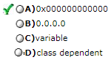

1. An ARP reply is normally _______.

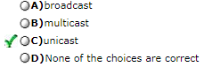

1. An ARP request is normally _______.

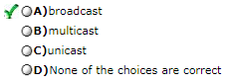

1. A technique called ______ is used to create a subnetting effect.

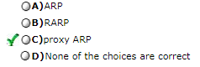

1. A _______ is an ARP that acts on behalf of a set of hosts.

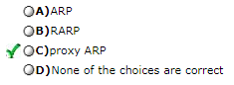

**3. Topic: Internet Control Message Protocol (ICMP)**

1. ICMP is a _________ layer protocol.

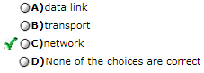

1. An ICMP message has _____ header and a variable-size data section.

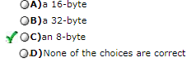

1. Which of the following is true about ICMP messages?

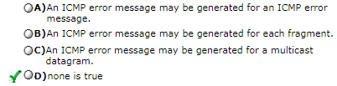

1. Which of the following is true about ICMP messages?

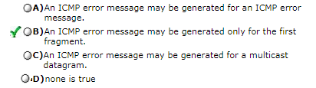

1. Which of the following is true about ICMP messages?

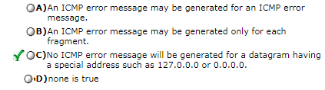

1. If a host needs to synchronize its clock with another host, it sends a _______ message.

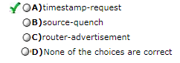

1. The purpose of echo request and echo reply is to _______

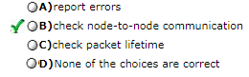

1. In error reporting the encapsulated ICMP packet goes to _______.

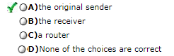

1. What field uniquely identifies the kind of ICMP message (for example, echo reply versus echo request)?

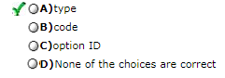

1. When the hop-count field reaches zero and the destination has not been reached, a _______ error message is sent.

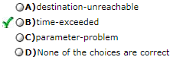

1. When all fragments of a message have not been received within the designated amount of time, a _______ error message is sent.

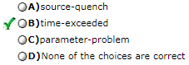

1. Errors in the header or option fields of an IP datagram require a _______ error message.

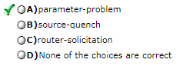

1. A _______ can learn about network _______ by sending out a router-solicitation packet.

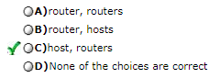

1. Who can send ICMP error-reporting messages?

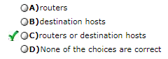

1. One method to alert a source host of congestion is the _______ message.

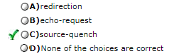

1. A time-exceeded message is generated if _______.

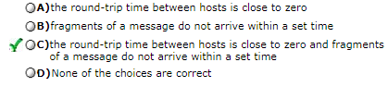

1. To determine whether or not a node is reachable, _______ message can be sent.

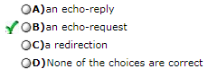

1. In calculating the time difference between two clocks, a negative value indicates _______.

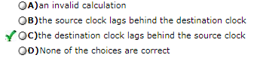

1. An IP datagram (datagram A) cannot reach its destination. An ICMP error message is sent to the source. The data field of the IP datagram (datagram B) that encapsulates the ICMP packet contains _______.

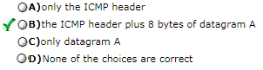

**4. Topic: User Datagram Protocol (UDP)**

1. UDP is called a ________________transport protocol.

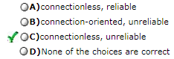

1. UDP does not add anything to the services of IP except for providing _______ communication.

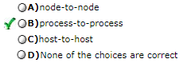

1. UDP is an acronym for _______.

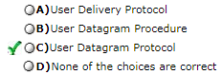

1. The local host and the remote host are defined using IP addresses. To define the processes, we need second identifiers called ____________ .

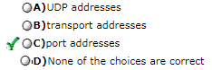

1. The ports ranging from 0 to 1,023 are assigned and controlled by ICANN. These are the ___________ ports.

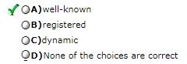

1. The ports ranging from 1,024 to 49,151 are called ___________ ports.

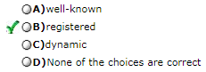

1. The ports ranging from 49,152 to 65,535 can be used as temporary or private port numbers. They are called the ________ ports.

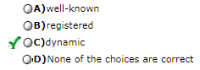

1. In the sending computer, UDP receives a data unit from the _______ layer.

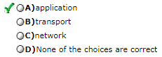

1. In the sending computer, UDP sends a data unit to the _______ layer.

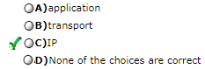

1. UDP and TCP are both _______ layer protocols.

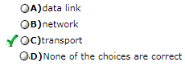

1. Which of the following functions does UDP perform?

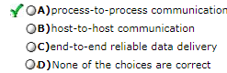

1. When the IP layer of a receiving host receives a datagram, _______.

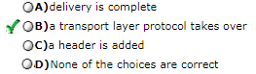

1. UDP needs the _______ address to deliver the user datagram to the correct application process.

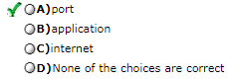

1. A port address in UDP is _______ bits long.

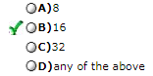

1. Which of the following does UDP guarantee?

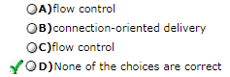

1. The source port address on the UDP user datagram header defines _______.

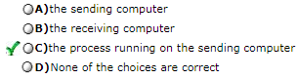

1. The combination of an IP address and a port number is called a ____________.

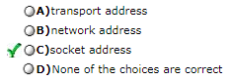

1. To use the services of UDP, we need ________ socket addresses.

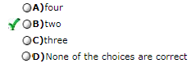

1. UDP packets are called __________ .

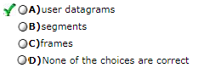

1. UDP packets have a fixed-size header of _______ bytes.

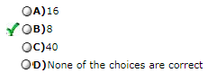

1. UDP packets are encapsulated in ___________ .

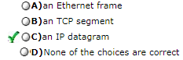

1. UDP uses ________ to handle outgoing user datagrams from multiple processes on one host.

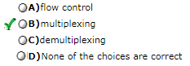

1. UDP uses _______ to handle incoming user datagrams that go to different processes on the same host.

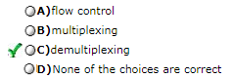

**5. Topic: Transmission Control Protocol (TCP)**

1. TCP is a __________protocol.

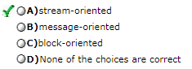

1. TCP groups a number of bytes together into a packet called a ___________.

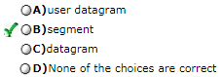

1. TCP is a(n) ___________ protocol.

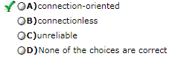

1. TCP is a(n) _______ transport protocol.

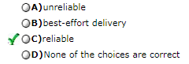

1. TCP uses _________________ to check the safe and sound arrival of data.

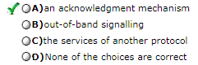

1. The bytes of data being transferred in each connection are numbered by TCP. The numbering starts with a __________________.

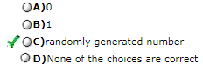

1. TCP assigns a sequence number to each segment that is being sent. The sequence number for each segment is the number of the _______ byte carried in that segment.

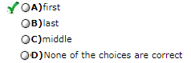

1. Communication in TCP is ___________.

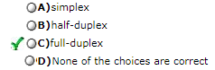

1. The value of the acknowledgment field in a segment defines the sequence number related to the ______byte a party expects to receive.

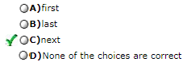

1. The inclusion of the checksum in the TCP segment is ________.

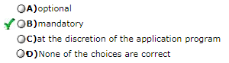

1. The inclusion of the checksum in the TCP segment is ________.

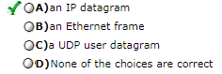

1. A SYN segment cannot carry data; it consumes _____ sequence number(s).

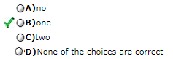

1. A SYN + ACK segment cannot carry data; it consumes _____ sequence numbers.

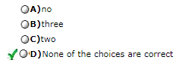

1. An ACK segment, if carrying no data, consumes ______ sequence number(s).

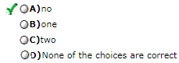

1. The connection establishment procedure in TCP is susceptible to a serious security problem called the _________ attack.

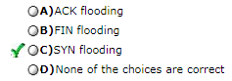

1. The SYN flooding attack belongs to a group of security attacks known as a _____ attack.

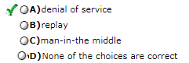

1. The FIN segment consumes ____ sequence numbers if it does not carry data.

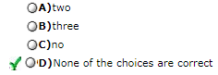

1. The FIN + ACK segment consumes _____ sequence number(s) if it does not carry data.

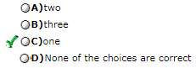

1. In TCP, one end can stop sending data while still receiving data. This is called a ______.

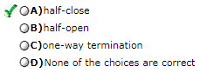

1. A(n) _________ machine is a machine that goes through a limited number of states.

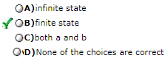

1. A common value for MSL is between___ seconds and ___ minute(s).

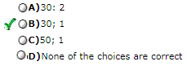

1. To accomplish flow control, TCP uses a ___________ window protocol.

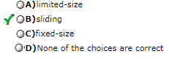

1. TCP sliding windows are __________ oriented.

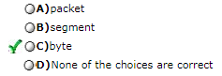

1. In TCP, the size of the send window is the ________ of rwnd and cwnd.

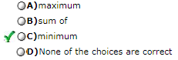

1. In TCP, the window should not be _________.

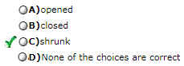

1. In TCP, the receiver can temporarily shut down the window; the sender, however, can always send a segment of _____ byte(s) after the window is shut down.

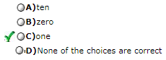

1. A serious problem can arise in the sliding window operation when either the sending application program creates data slowly or the receiving application program consumes data slowly, or both. This problem is called the ______.

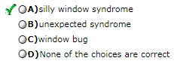

1. Nagle's algorithm can solve the silly window syndrome created by the _________.

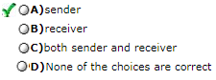

1. Clark's solution can solve the silly window syndrome created by the _________.

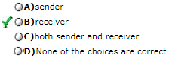

1. Delayed acknowledgment can solve the silly window syndrome created by the _________.

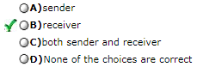

1. ACK segments consume _______ sequence number(s) and _______ acknowledged.

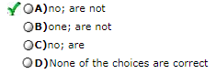

1. In modern implementations of TCP, a retransmission occurs if the retransmission timer expires or ________ duplicate ACK segments have arrived.

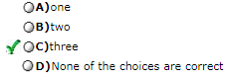

1. In TCP, ________ retransmission timer is set for an ACK segment.

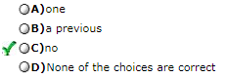

1. Lost acknowledgments may create a _______ if they are not handled properly.

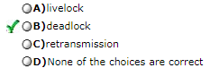

1. In the ________ algorithm the size of the congestion window increases exponentially until it reaches a threshold.

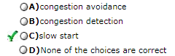

1. In the __________ algorithm the size of the congestion window increases additively until congestion is detected.

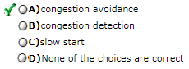

1. In the congestion detection algorithm, if detection is by a time-out, a new _______ phase starts.

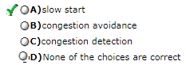

1. In the congestion detection algorithm, if detection is by three ACKs, a new _______ phase starts.

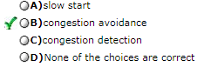

1. In TCP, there can be ______ RTT measurement(s) in progress at any time.

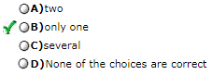

1. The value of the window scale factor can be determined during __________.

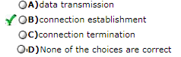

1. Multiply the header length field by _______ to find the total number of bytes in the TCP header.

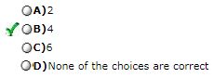

1. Urgent data requires the urgent pointer field as well as the URG bit in the _______ field.

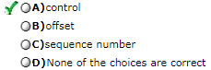

1. The options field of the TCP header ranges from 0 to _______ bytes.

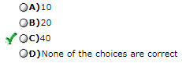

1. Which option defines the maximum number of bytes in a TCP segment?

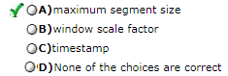

1. If the ACK value is 200, then byte _______ has been received successfully.

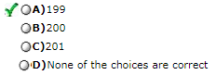

**6. Topic: Stream Control Transmission Protocol (SCTP)**

1. Stream Control Transmission Protocol (SCTP) is a new _____________protocol.

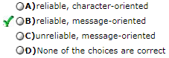

1. SCTP allows __________ service in each association.

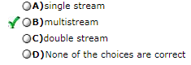

1. SCTP association allows _____________ for each end.

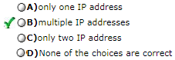

1. In SCTP, a data chunk is numbered using ________.

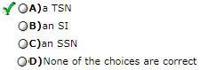

1. To distinguish between different streams, SCTP uses ___________.

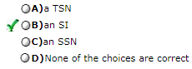

1. To distinguish between different data chunks belonging to the same stream, SCTP uses ___________.

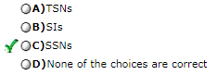

1. TCP has ____________; SCTP has ____________.

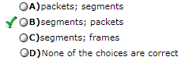

1. The control information in SCTP is included in the ________.

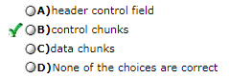

1. An SCTP packet can carry __________.

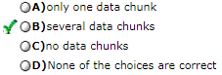

1. Options in SCTP are _______________________.

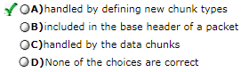

1. The general header in SCTP is _______ bytes.

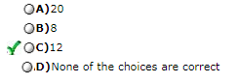

1. An SCTP sequence number (TSN) is located in the _______.

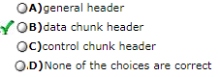

1. The checksum in SCTP is ________ bits.

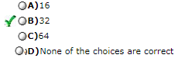

1. The association identifier in SCTP is __________________.

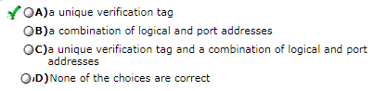

1. The association identifier in SCTP cannot be a combination of logical and port addresses because of ________________.

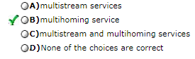

1. In SCTP, control information and data information are carried in _______.

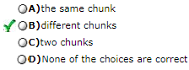

1. Control chunks in SCTP ___________________.

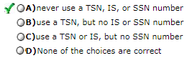

1. In SCTP, acknowledgment numbers are used to acknowledge _____________.

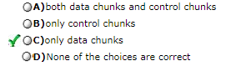

1. In an SCTP packet, control chunks come ___________ data chunks.

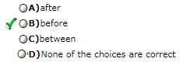

1. In SCTP, chunks need to terminate on a _______boundary.

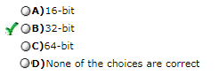

1. In SCTP, the data field of the DATA chunk must carry at least _________ byte of data, which means the value of length field cannot be less than ___________.

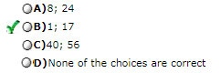

1. In SCTP, ___________ can be carried in a packet that carries an INIT chunk.

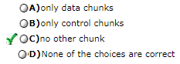

1. A connection in SCTP is called a(n) ____________.

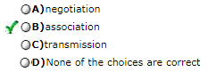

1. The acknowledgment in SCTP defines the cumulative TSN, the TSN of the ____________ .

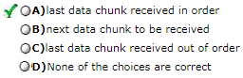

1. A DATA chunk arrives with its B/E bits equal to 0/0. It is ___________.

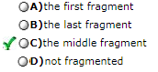

1. A DATA chunk arrives with its B/E bits equal to 0/1. It is

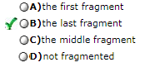

1. A DATA chunk arrives with its B/E bits equal to 1/0. It is ___________.

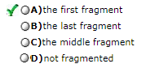

1. A DATA chunk arrives with its B/E bits equal to 1/1. It is ___________.

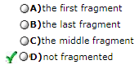

1. Which chunk is not involved in association establishment?

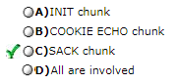

1. Which chunk probes the condition of an association?

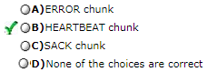

1. The _______ chunk is sent when an end point finds an error in a received packet.

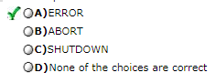

**7. Topic: Multicasting and Multicast Routing Protocol (MRP)**

1. A one-to-all communication between one source and all hosts on a network is classified as a _______ communication.

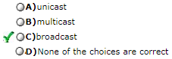

1. A one-to-many communication between one source and a specific group of hosts is classified as a _______ communication.

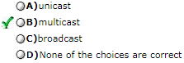

1. A one-to-one communication between one source and one destination is classified as a _______ communication.

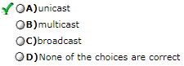

1. In ______, the router forwards the received packet through only one of its interfaces.

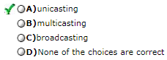

1. In _______, the router may forward the received packet through several of its interfaces.

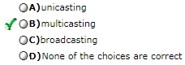

1. Emulation of ________ through ___________ is not efficient and may create long delays.

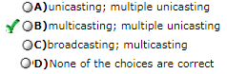

1. In unicast routing, each router in the domain has a table that defines a ______ path tree to possible destinations.

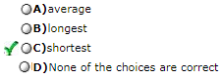

1. In multicast routing, each involved router needs to construct a ________ path tree for each group.

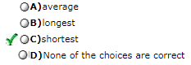

1. In the _______ tree approach, each router needs to have one shortest path tree for each group.

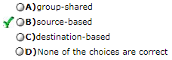

1. In the group-shared tree approach, ________ is/are involved in multicasting.

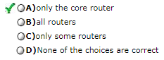

1. Multicast link state routing uses the _______ tree approach.

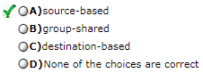

1. The Multicast Open Shortest Path First (MOSPF) protocol is an extension of the OSPF protocol that uses multicast routing to create source-based trees. The protocol is based on _______ routing.

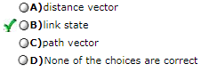

1. MOSPF is a _______ protocol.

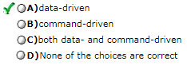

1. _________ broadcasts packets, but creates loops in the systems.

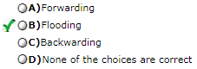

1. In RPF, a router forwards only the copy that has traveled the _______ path from the source to the router.

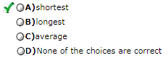

1. RPF eliminates the ________ in the flooding process.

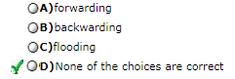

1. RPB creates a shortest path _______ tree from the source to each destination.

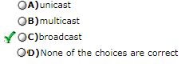

1. RPB guarantees that each destination receives _________ of the packet.

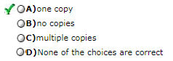

1. In ________, the multicast packet must reach only those networks that have active members for that particular group.

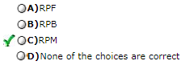

1. _______ adds pruning and grafting to _______ to create a multicast shortest path tree that supports dynamic membership changes.

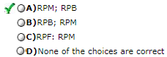

1. __________ is an implementation of multicast distance vector routing. It is a source-based routing protocol, based on RIP.

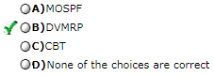

1. DVMRP is a ________routing protocol, based on RIP.

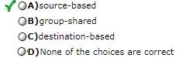

1. Pruning and grafting are strategies used in _______.

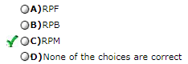

1. A _______ message tells an upstream router to stop sending multicast messages for a specific group through a specific router.

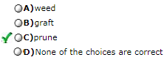

1. A _______ message tells an upstream router to start sending multicast messages for a specific group through a specific router.

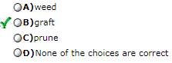

1. CBT is a ________ protocol that uses a core as the root of the tree.

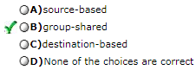

1. PIM-DM is used in a _______ multicast environment.

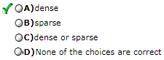

1. PIM-SM is used in a _______multicast environment such as a WAN.

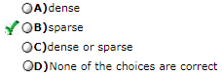

1. In _______, a logical tunnel is established by encapsulating the multicast packet inside a unicast packet.

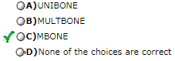

**8. Topic: Transport Layer**

1. One of the main duties of the transport layer is ____________ communication.

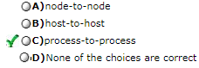

1. The client program normally uses ____________ port number.

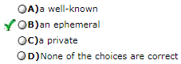

1. The server program normally uses __________ port number.

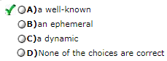

1. A socket address is a combination of __________

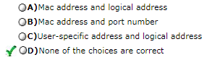

1. ______________ means accepting items from more than one source.

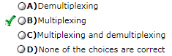

1. ______________ means delivering items to more than one source.

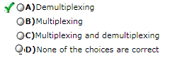

1. _________ means the producer delivers the items when they are produced without waiting for the request from the consumer

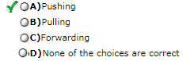

1. _________ means the consumer takes the items when it is ready to do so.

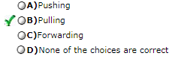

1. In the stop-and-wait protocol, the send window size is ______ and the receive window size is _______ where n is related to the number of bits in the sequence.

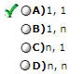

1. In the go-back-N protocol, the send window size is ______ and the receive window size is _______, where n is related to the number of bits in the sequence number.

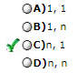

1. In the selective-repeat protocol, the send window size is ______ and the receive window size is _______, where n is related to the number of bits in the sequence.

